Instructions for completing ‘Gleaners and Searchers’ answers using Adobe Reader

If you can’t open the Gleaners and Searchers PDF file, then ask an adult to download Adobe Reader for free by going to:  
<http://get.adobe.com/uk/reader/> or <http://www.adobe.com/uk/products/reader.html>

Dear Gleaners and Searchers,

These notes are intended to help you to have fun answering the different types of Bible Class questions from ‘Youthful Days’ using your computer. If you are stuck on how to answer any question, simply follow these instructions by looking up the section that relates to your question. Ask an adult if you still can’t get it to work. Once you have found out how to do it the first time, you should be able to do it the next time.

Fill in your name, age and address by highlighting the text to select it, then delete it and replace it with your information.

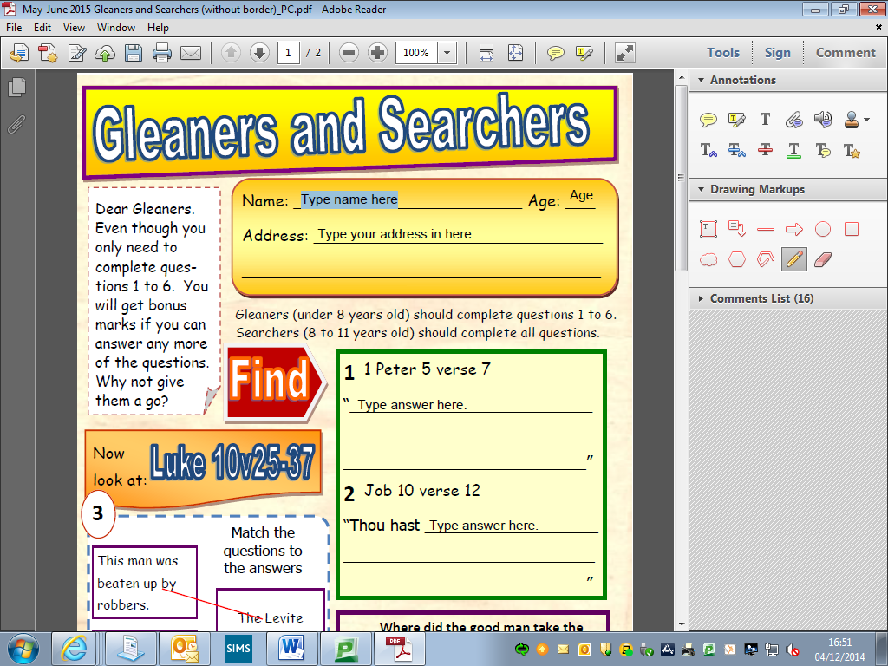

Complete the questions by simply highlighting and deleting the text and replacing it with your answer.

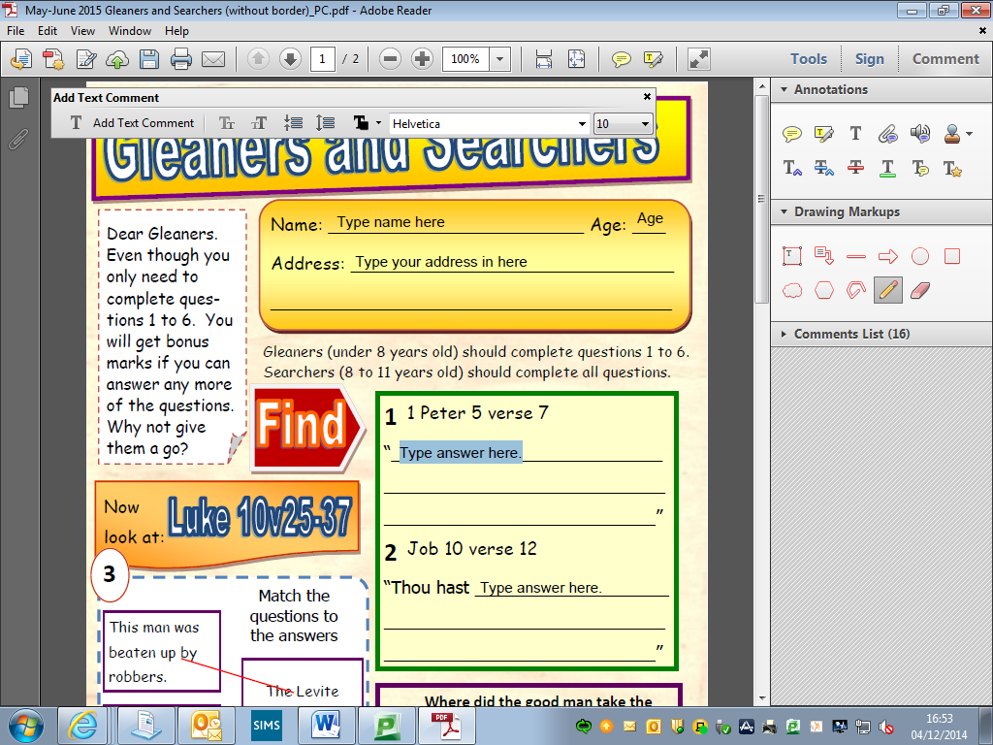

1. Click on the “Comment” button at the top right of the screen.

You will need to draw lines between the boxes for this question.

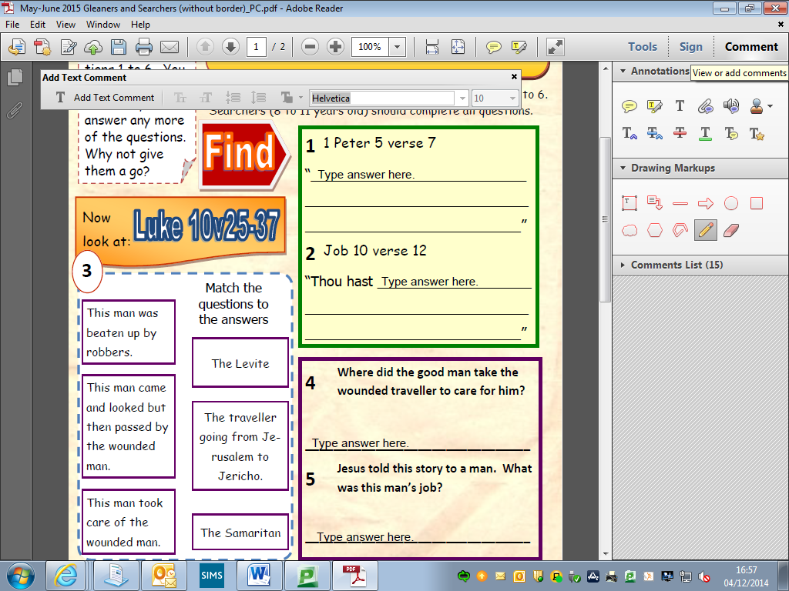

1. Then click on “Drawing Markups”
2. Then click on the line symbol.
3. Click where you would like the line to start and drag to where you would like it to finish. Let go of the mouse button. You will now have a line.

If you need to move it then simply click on the line and drag it to where you want it.

1. Click on the “Comments” button at the top right of the screen.

You will need to draw a circle around the correct answer in this question.

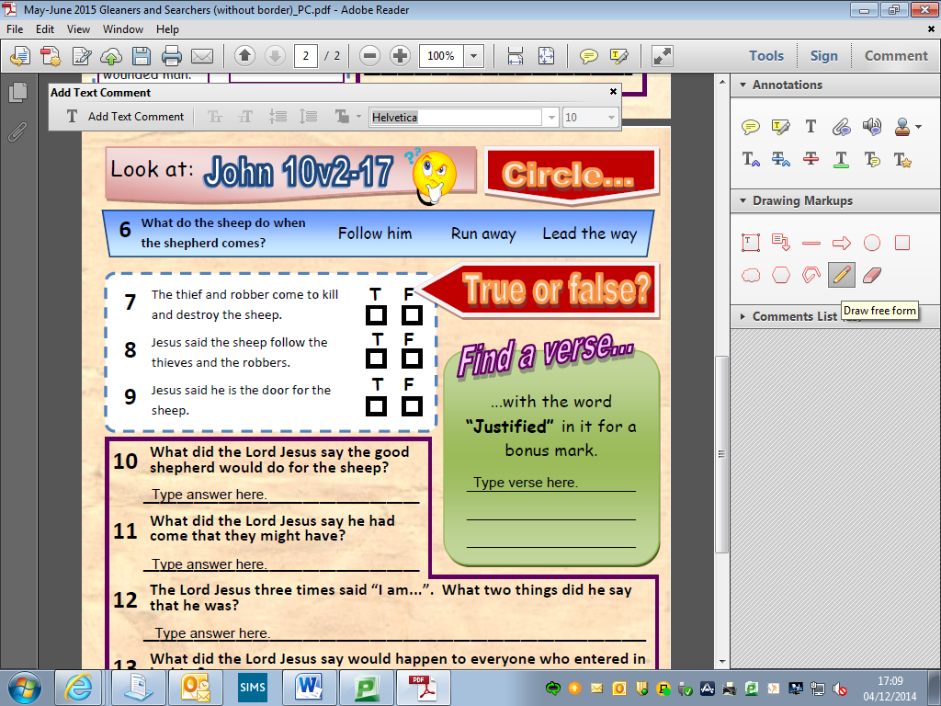

1. Then click on “Drawing Markups”
2. Then click on the Pencil symbol.
3. Use the rubber if you make a mistake.

You will need to place a tick in the box with the correct answer.

Follow the instructions for **Question 6** and use the pencil tool to draw a tick in the correct box.